Health monitoring platform instructive

# Main Window:

The health monitoring platform has 3 options: Data Acquisition, Training/Validation and Monitoring. Each option will open a different window, with its own graphics and functionalities, which will be explained in this document.

# Data Acquisition:

The data acquisition window lets us monitor the real time signal of the sensors with have connected to our computer. It will automatically detect the DAQs we have connected and once we chose the sensors from which we want to acquire the data, it will show the Real Time acceleration and the calculate the PSD, FRF or coherence, depending on which one is selected, updating it according to the time on the text edit field called Period.

On the upper left side of the window, we can specify the conditions for our data reading. We have the sample rate that is the number of samples we are going to take each second; the period, which is the time span we will use for calculating the PSD and the FRF; the damage percentage which we can specify in order to use the acquired data as a base for damage classification; the block size, and overlap, both used for the calculation of FRF, PSD and coherence with the functions pwelch and cpsd

After stablishing the parameters, we can click on the search button so the system will identify the DAQ connected and show all the possible entries. Then we check the ones we are going to use and click connect. The real time graph will appear in the center of the window and after the specified time the PSD, FRF or Coherence graph will also be displayed.

You can choose will graph to display in the lower right corner, just selecting it. It will refresh once the given period is completed. For the FRF, if you don’t have any input selected it will automatically chose the first sensor or entry as the input signal and the rest as the outputs or response signals.

“Set input”, only one input can be selected, if a second one is selected it will replace the first one.

You can also add the output signals with the button “Set output”, although the app will automatically display the rest as output in the graph.

Finally, you can click the “disconnect” button in order to stop the graphics and data reading, and then save the database typing the name for it on the upper right text edit field and clicking on the save button.

The database will be exported and saved in MATLAB’s path folder. The data it stores contains all the information from the Edit fields, the selected inputs and outputs displayed on the text fields and a Timetable with all the data collected from the sensors with their respective timestamp.

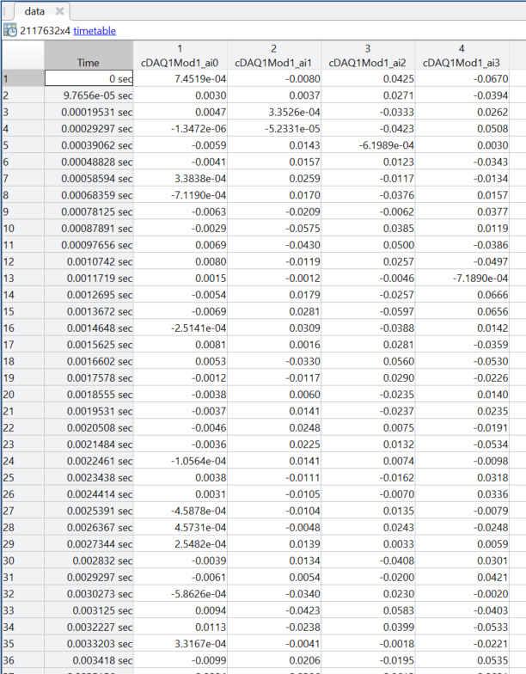

# Training/Validation:

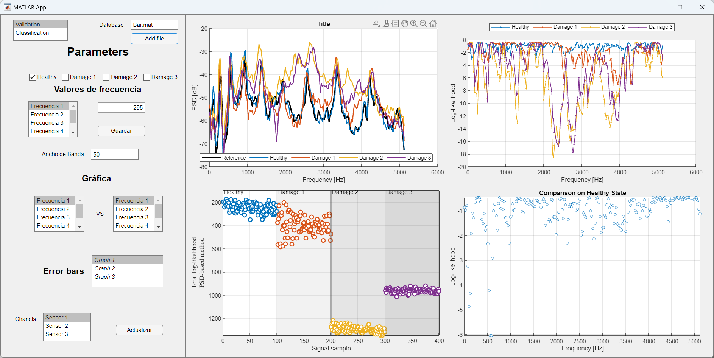The Validation window has multiple features, including 4 graphs: PSD graphs Coherence graph, Total Log-likelihood vs signal sample, and Comparison on healthy state.

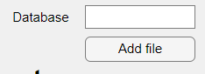

Firstly, there is the option to add a file serving as a database, its extension must be ".mat", and it will contain sensor data under 4 damage conditions: "Healthy", "Damage 1", "Damage 2", "Damage 3", "Damage 4".

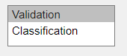

Moreover, there is the option to validate or classify the data; by default, it is set to validation, and if classification is required, this option should be changed.

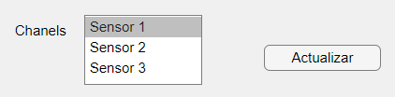

Additionally, the signal channel can be changed. If analysis of a specific sensor is needed, the channel option should be adjusted.

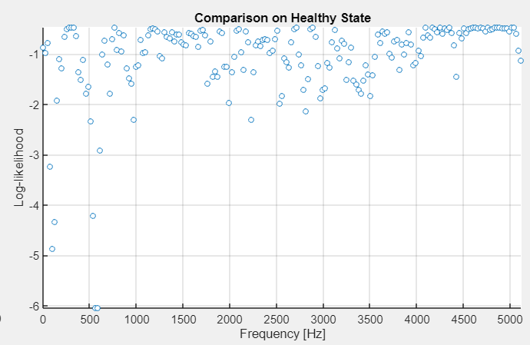Within the Log-likelihood graph, one can select the data to be represented. The checkboxes that are marked will display the states that will be visualized.

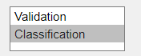

Once the validation graph display is complete, classification graphs follow.

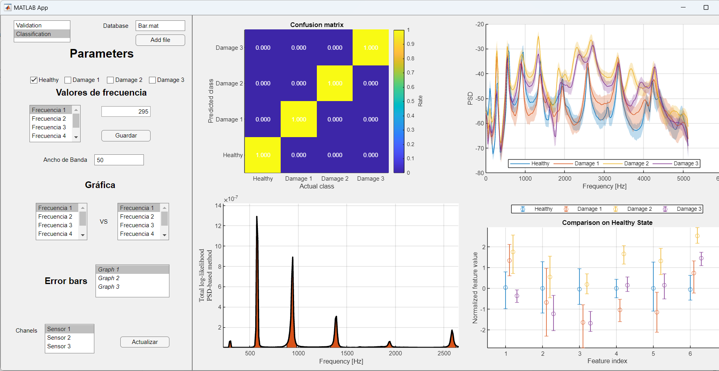For data classification, 4 graphs are shown: Confusion matrix, Mean PSD graph, Bandwidth frequencies, and Error bars based on states.

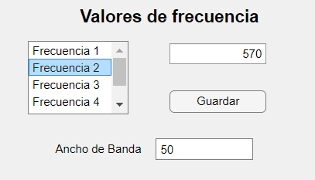

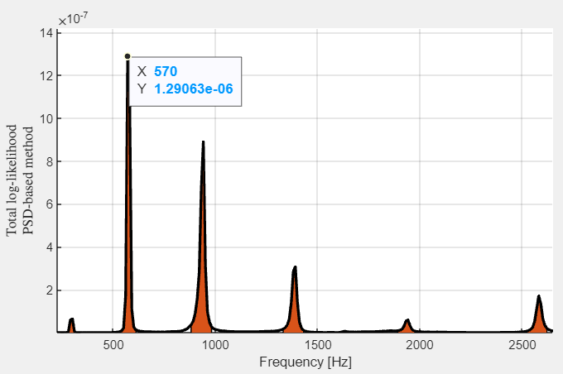In the Bandwidth frequencies option, the bandwidth and frequencies to be analyzed can be selected. The value of each frequency can be updated, and the save button must be pressed to perform another analysis.

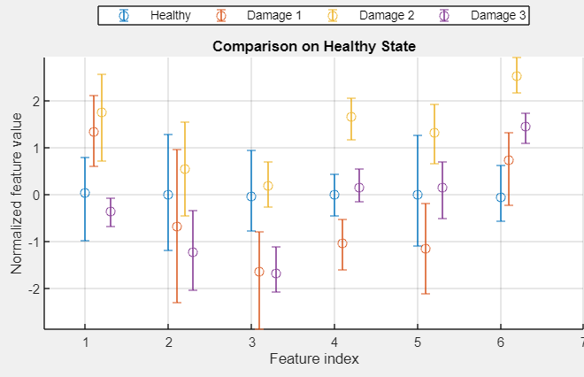

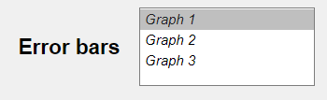

In the error bars graph, the graph to be analyzed can be selected, and it will update automatically without needing to press the save button.